



USER

GUIDE

USER GUIDE

Cash Transfer

N EW D E L H I

S EP T EM B ER 2 0 2 2

Table of Contents

1. Cash Transfer 3

1.1 Eligible 4

1.2 First Verification 5

1.3 Second Verification 8

1.4 Approval 11

1.5 Payment 14

# Cash Transfer

The Cash Transfer module is developed to manage and track cash transfer flow of registered participants and its approvals. Click on the **Cash Transfer** option from **Burger** menu to access this module. This module is cohort, installment and cash transfer status driven. The cash transfer contains five steps for each installment –

1. Eligible
2. First Verification
3. Second Verification
4. Approval
5. Payment

Each cash transfer step has to go through an approval process by authorized users to move forward with the next step. Below table explains the actions to be performed in each cash transfer step by the authorized users -

|  |  |  |  |  |  |  |  |  |  |  |  |
| --- | --- | --- | --- | --- | --- | --- | --- | --- | --- | --- | --- |
| # | Eligible | | First Verification | | Second Verification | | Approval | | Payment | | |
| # | Export | Import | Export | Import | Export | Import | Export | Import | Export | Import | Bank Payment |
| Administrator | **Checkmark** | ─ | **Checkmark** | **Checkmark** | **Checkmark** | **Checkmark** | **Checkmark** | **Checkmark** | **Checkmark** | **Checkmark** | **Checkmark** |
| Program Coordinator | **Checkmark** | ─ | Checkmark | Checkmark | Checkmark | ─ | Checkmark | ─ | Checkmark | ─ | ─ |
| Lead Partner | Checkmark | ─ | Checkmark | ─ | Checkmark | Checkmark | Checkmark | ─ | Checkmark | ─ | ─ |
| Program Manager | Checkmark | ─ | Checkmark | ─ | Checkmark | ─ | Checkmark | Checkmark | Checkmark | ─ | ─ |
| Treasury | Checkmark | ─ | Checkmark | ─ | Checkmark | ─ | Checkmark | ─ | Checkmark | Checkmark | Checkmark |

## 1.1 Eligible

The first Cash Transfer step allows you to view the participants eligibility list (see below figure). You also have the option to view the reason for not eligibility of participants.

*“Only the participants with eligibility status Yes will be moved to next cash transfer step i.e. First Verification.”*

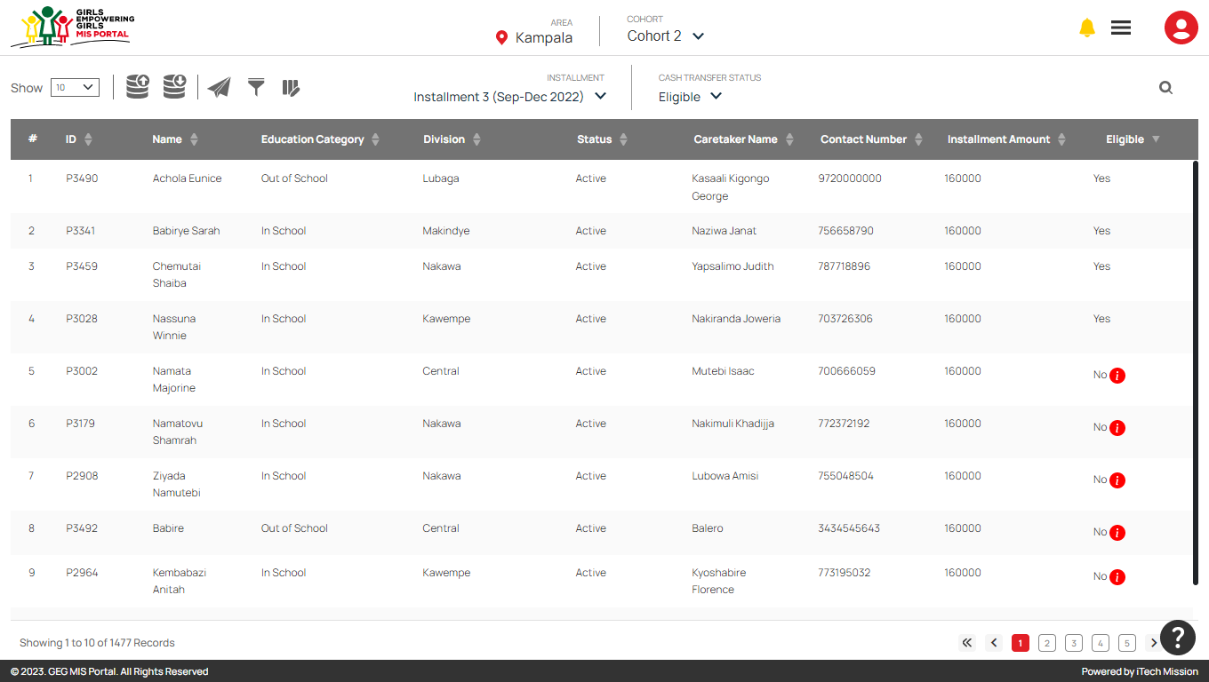

Hover over on the **Information** icon from the Eligible column to view the reason for eligible status of the selected participant to be No.

Click on the **Export** button to download the participant eligibility in CSV file format.

****Click on **Send Notification** button in order to notify the program coordinator to start the next step of Cash Transfer process.

## 1.2 First Verification

In this step of cash transfer process, the eligible participants have to be verified by the Program Coordinator to move to the next step of cash transfer process. **Program Coordinator** will receive notification to start First verification of the eligible participants. Login as program coordinator and click on the notification button to view the received notification (see below figures).

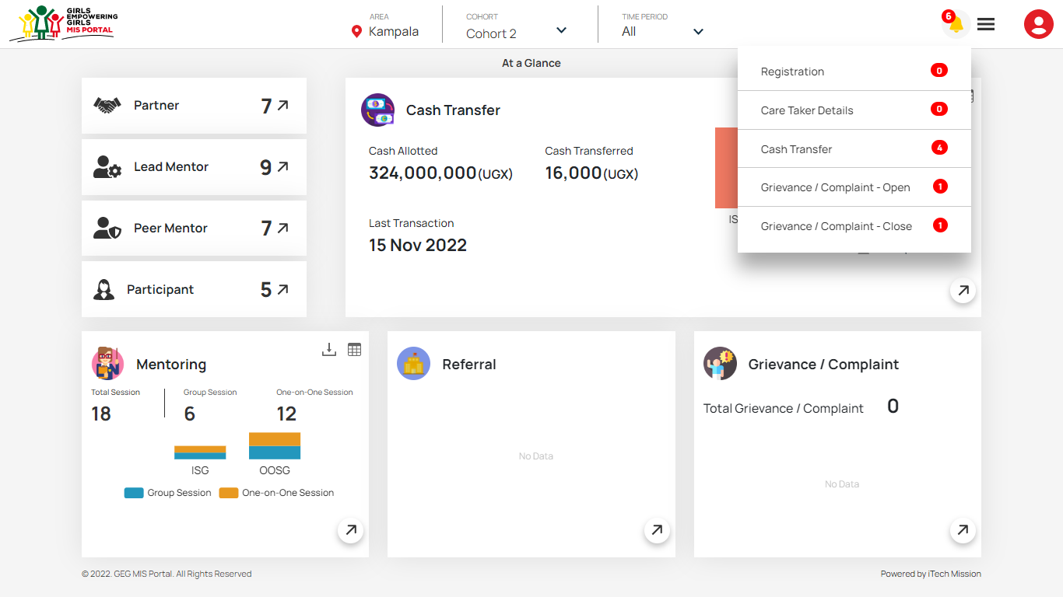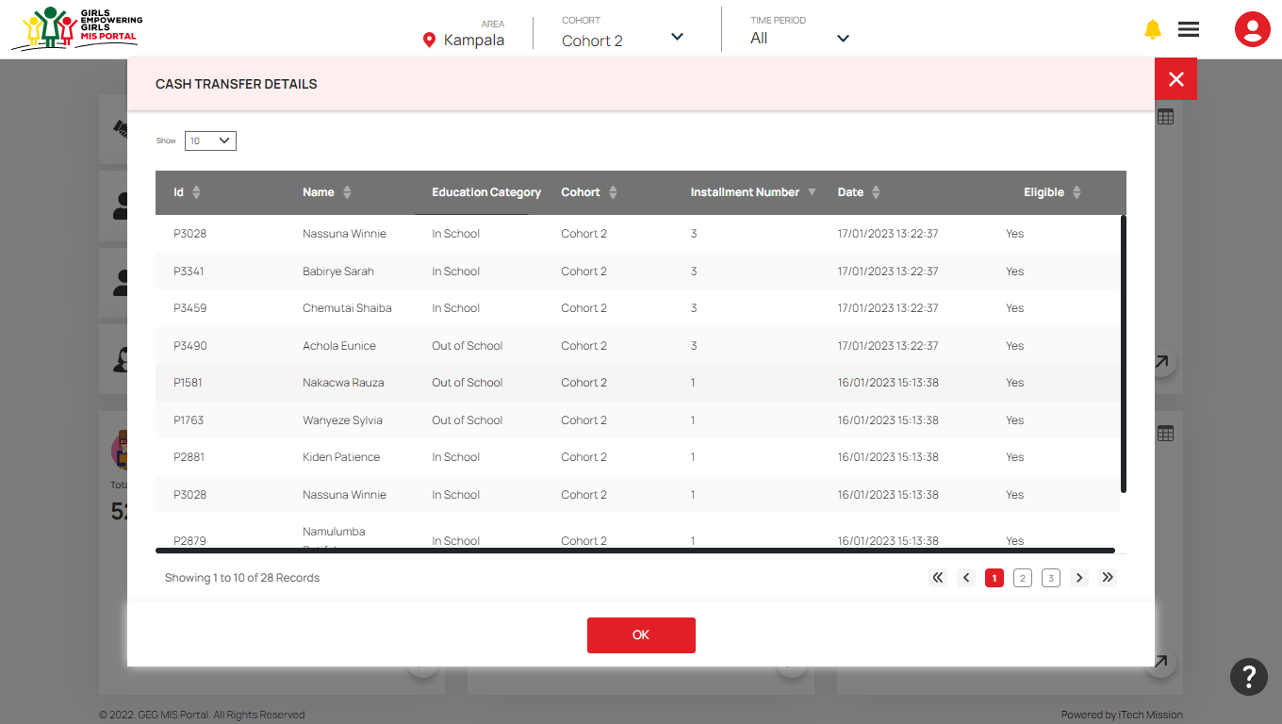

To approve first verification, navigate to **Cash Transfer** module and view the list of participants available in First Verification cash transfer status. Click to select Yes/No from the First Verification column to complete the first verification step of selected participant. If clicked **Yes**, theparticipant is verified and will be moved to next cash transfer process.

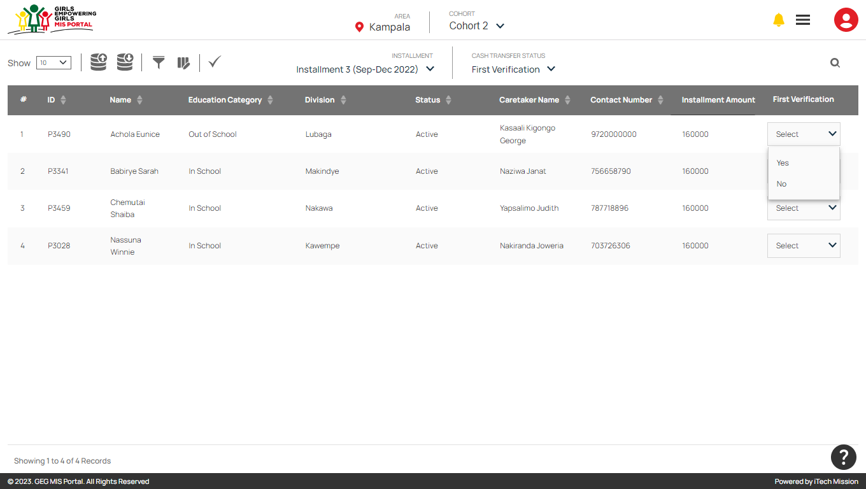

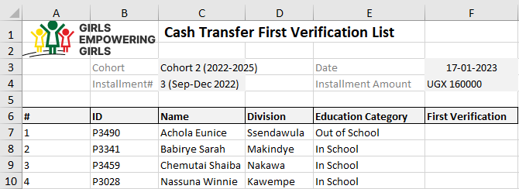Click on the **Export** button to download the first verification template structure in CSV file format (see below figure).

To complete the first verification process of bulk participants at once, you can edit the downloaded first verification file and enter Yes or No in First Verification column then upload the file by clicking on **Import** option (see below figures). You can also click on **Verify All** button to verify all the participants.

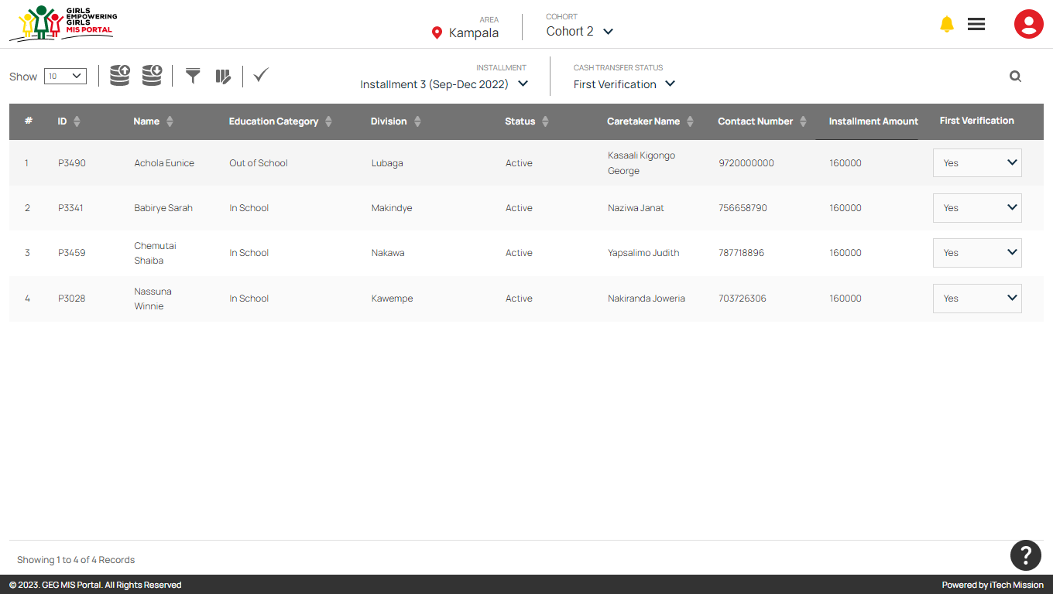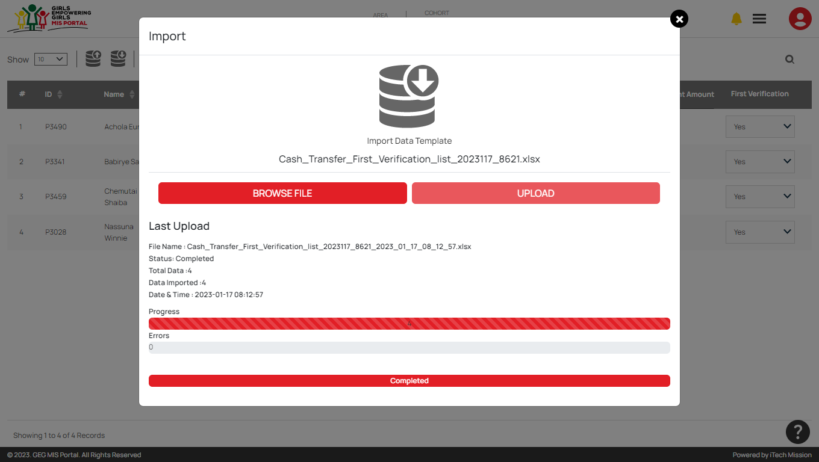

*“Only the participants with first verification status as Yes will be moved to next cash transfer step i.e. Second Verification.”*

## 1.3 Second Verification

In this step of cash transfer process, the participants have to be verified by the **Lead Partner** to move to the next step cash transfer process. Lead partner will receive notification when the participants will be moved to the second verification step of cash transfer process. Login as lead partner and click on the notification button to view the received notification (see below figure).

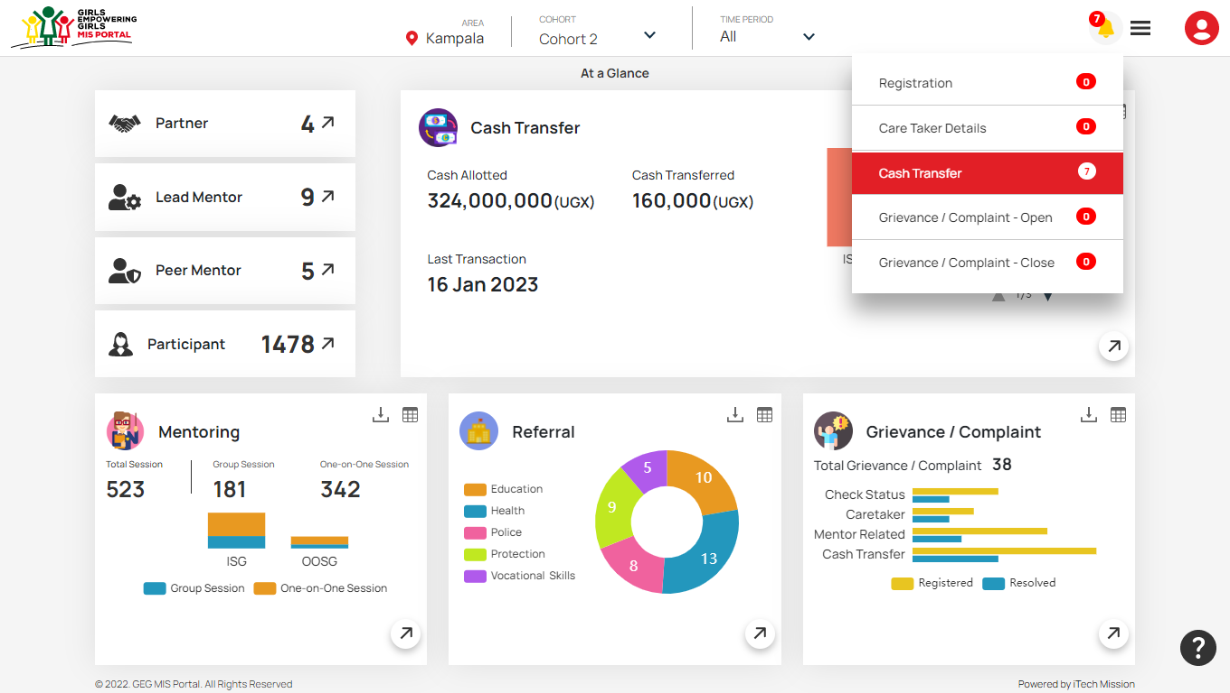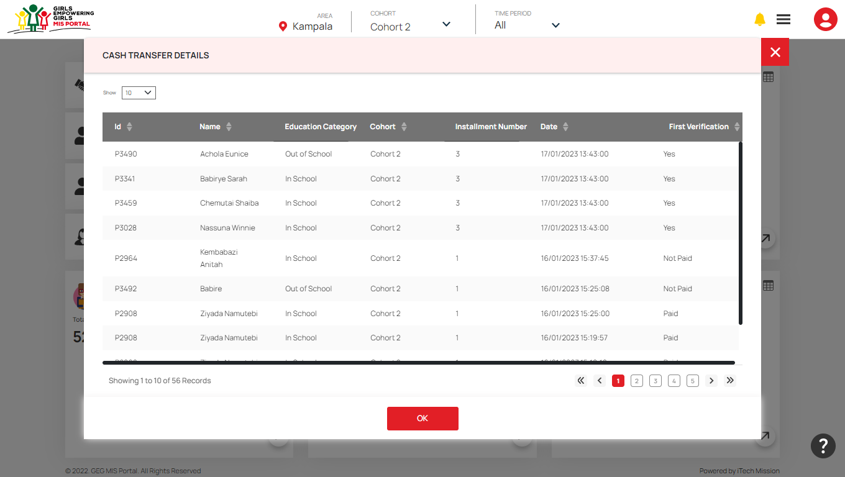

To approve second verification, navigate to Cash Transfer module and select Second Verification from the cash transfer status dropdown. Click to select Yes/No from the Second Verification column to complete the second verification of selected participant. If clicked **Yes**, theparticipant is verified and will be moved to next step of cash transfer process.

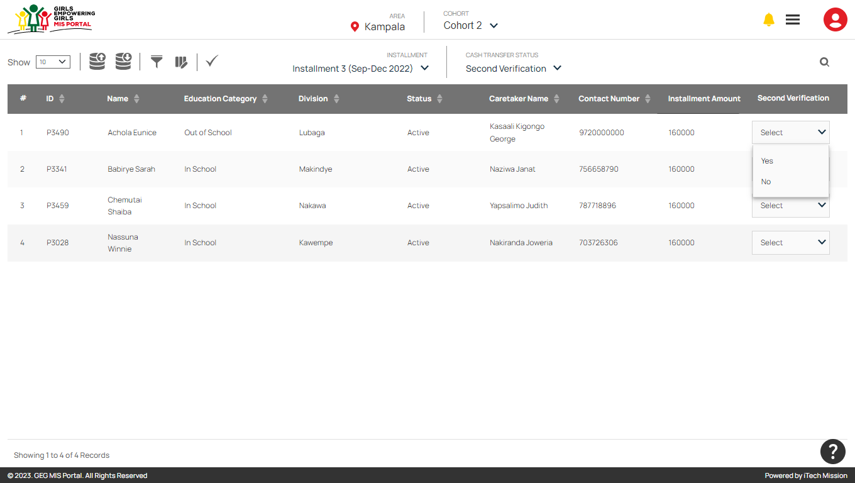

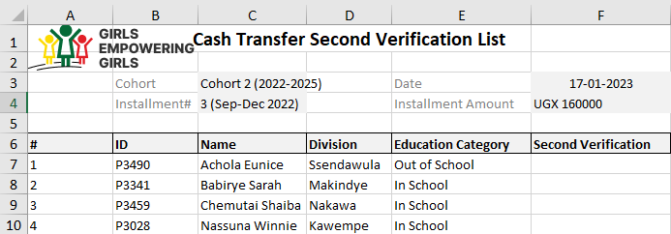Click on the **Export** button to download the second verification template structure in CSV file format (see below figure).

To Complete the second verification process of bulk participants at once, you can edit and the downloaded second verification file and enter Yes or No in Second Verification column then upload the file by clicking on **Import** option (see figure below). You can also click on **Verify All** button to verify all the participants.

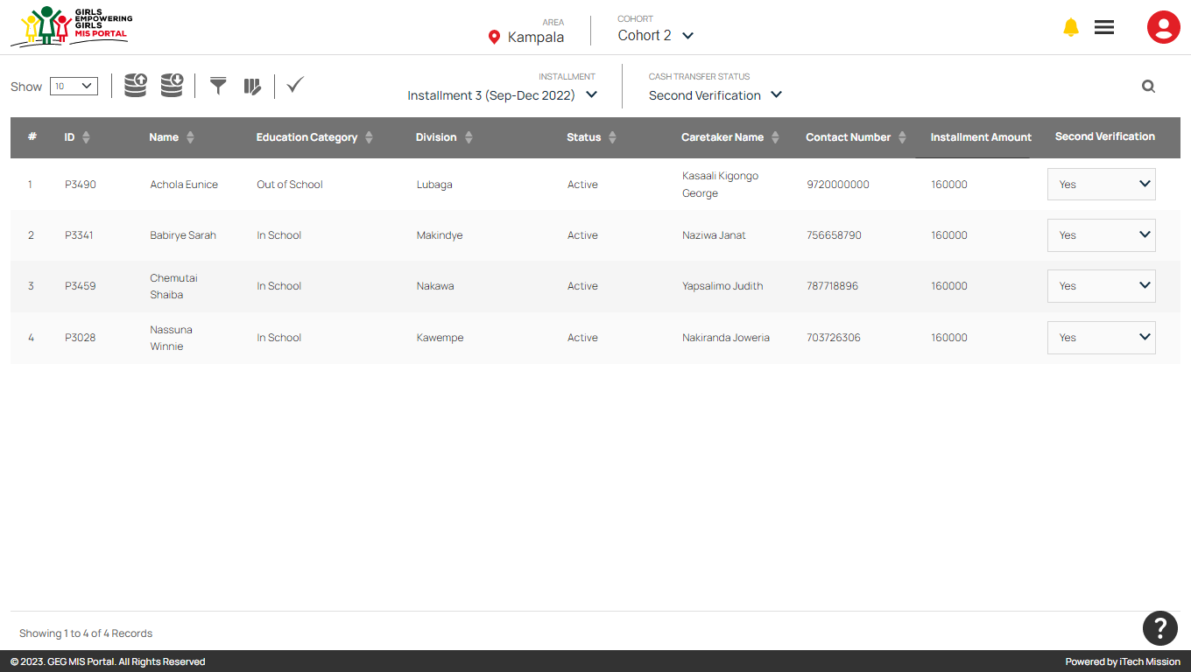 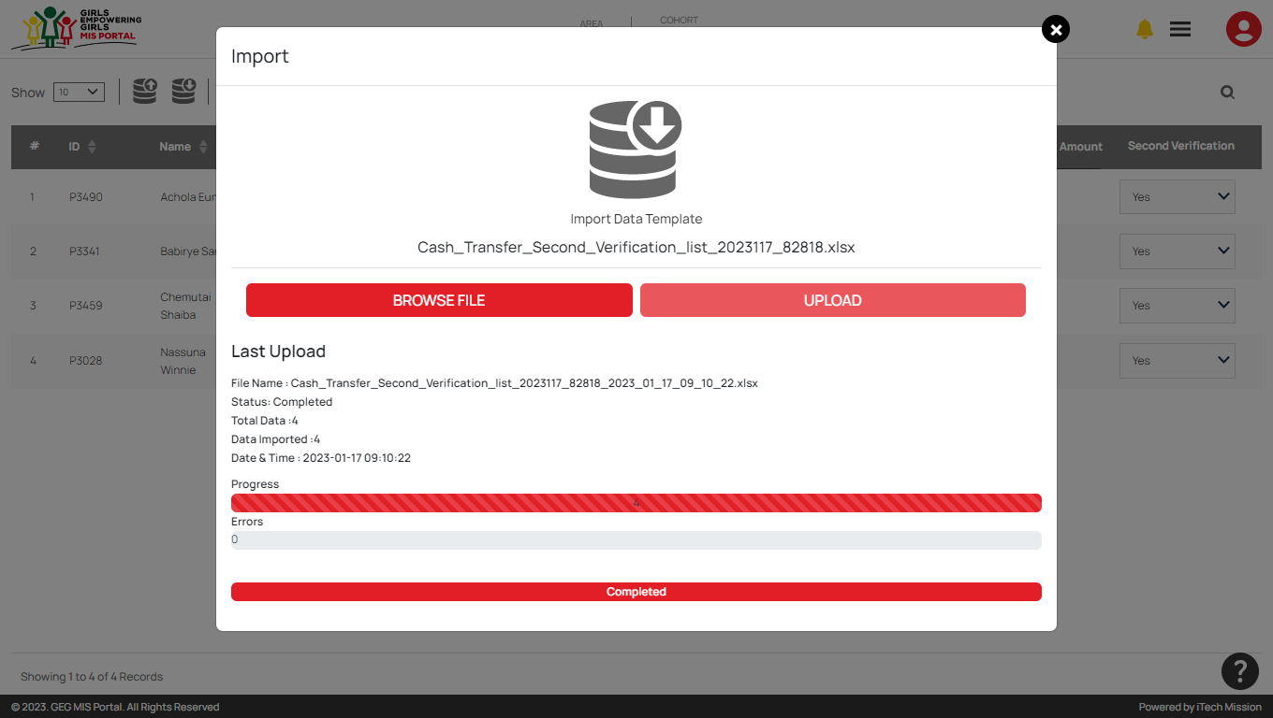

*“Only the participants with second verification status as Yes will be moved to next cash transfer step i.e., Approval.”*

## 1.4 Approval

In this step of cash transfer process, the program manager will approve the payment of the selected participants. Program manager will receive notification when the participants will be moved to the approval step of cash transfer process. Login as program manager and click on the notification button to view the received notification (see below figures).

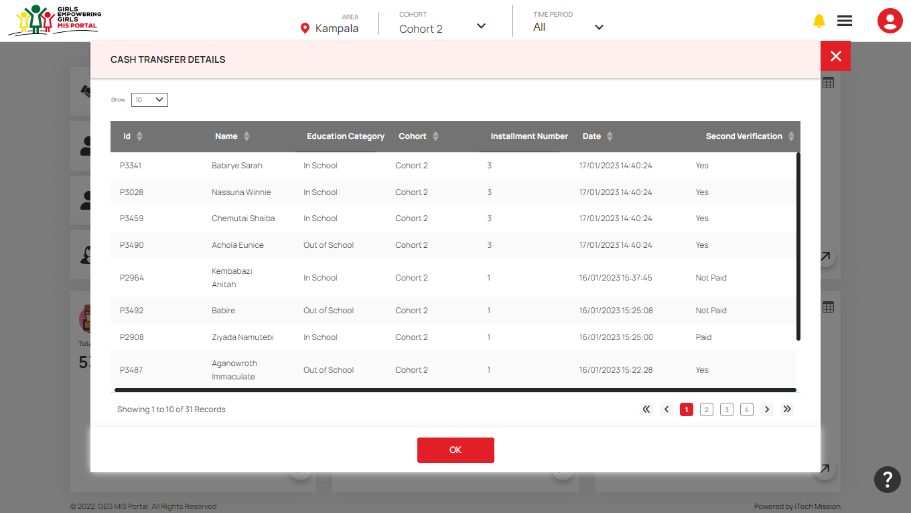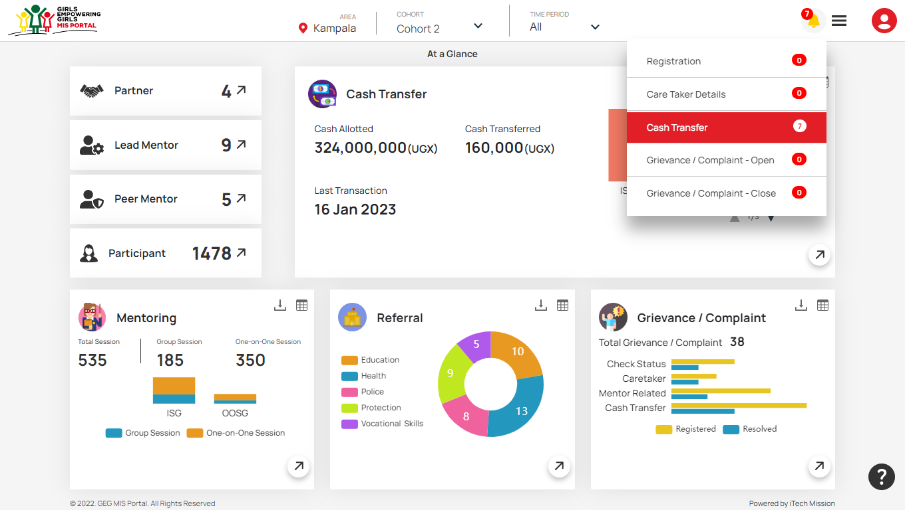

To approve payment, navigate to **Cash Transfer** module and select **Approval** from cash transfer status dropdown. Click to select Yes/No from the Approval column to complete the payment approval of selected participant (see below figure). If clicked **Yes**, the paymentparticipant is verified and will be moved to next step of cash transfer process.

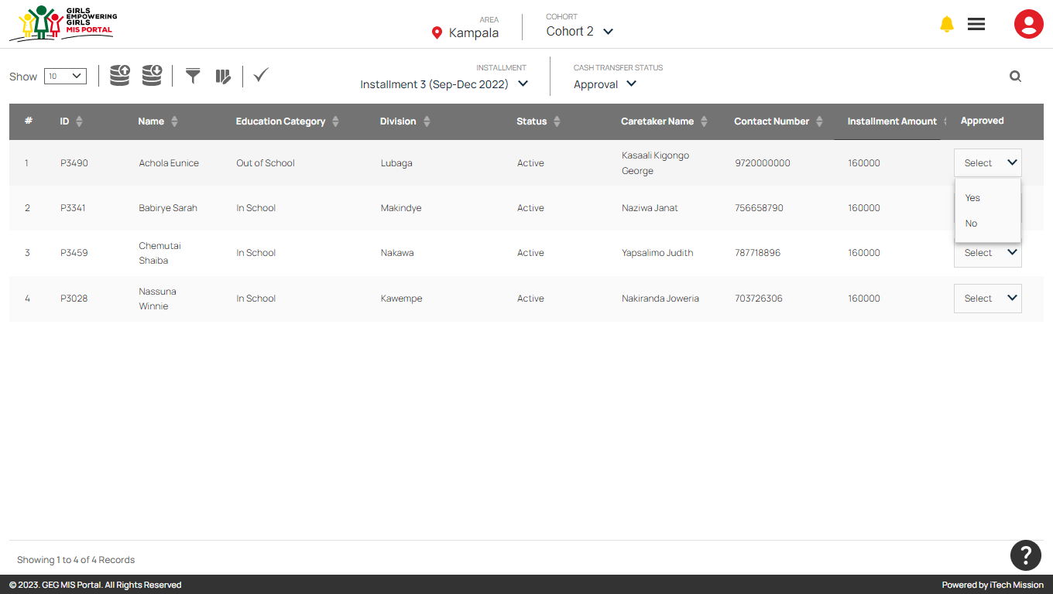

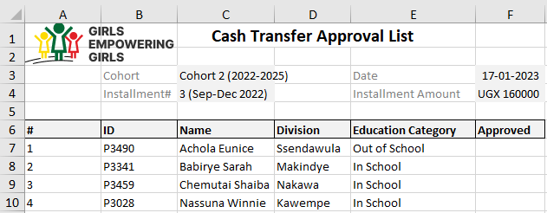Click on the **Export** button to download the approval template structure in CSV file format (see below figure).

To complete the approval process of bulk participants at once, you can edit the downloaded approval file and enter Yes or No in Approved column then upload the data file by clicking on **Import** option (see below figures). You can also click on **Approve All** button to approve all the participants.

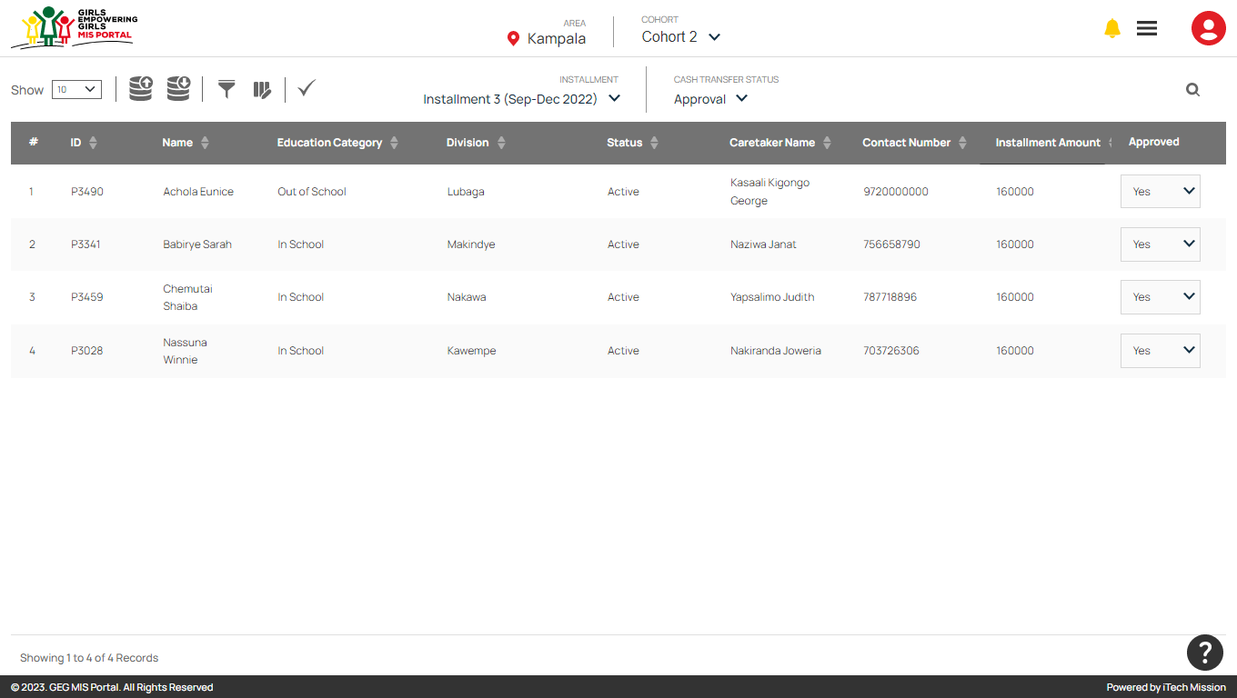 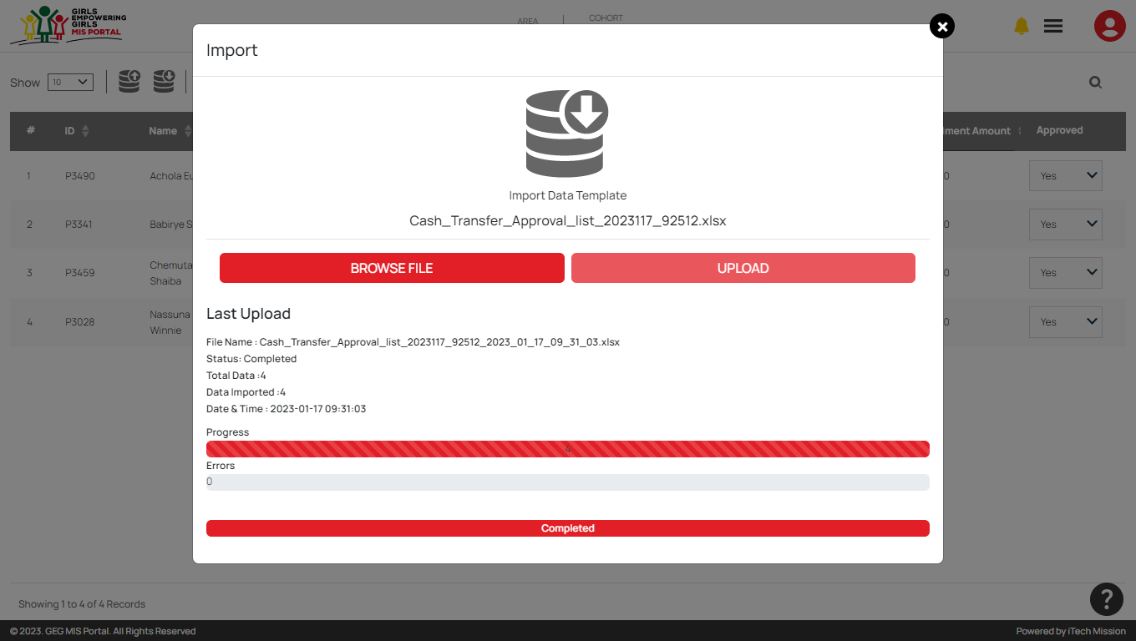

*“Only the participants with approval status as Yes will be moved to next cash transfer step i.e., Payment.”*

## 1.5 Payment

In this step of cash transfer process, the **Treasury** will update the payment status of participants. Treasury will receive notification when the participants will be moved to the payment step of cash transfer process. Login as treasury and click on the notification button to view the received notification (see below figures).

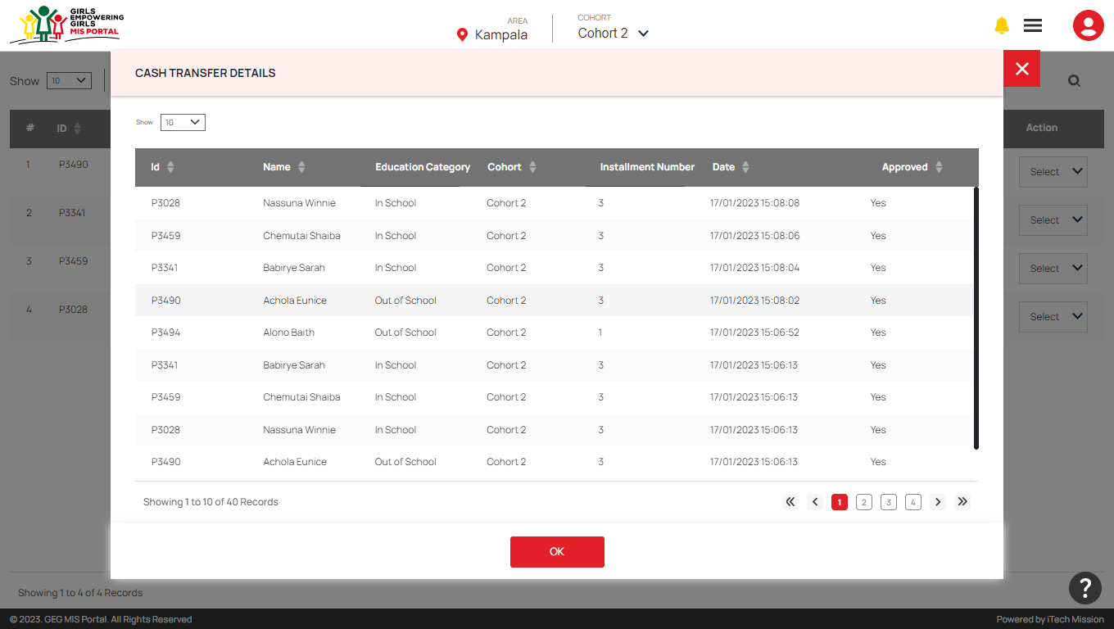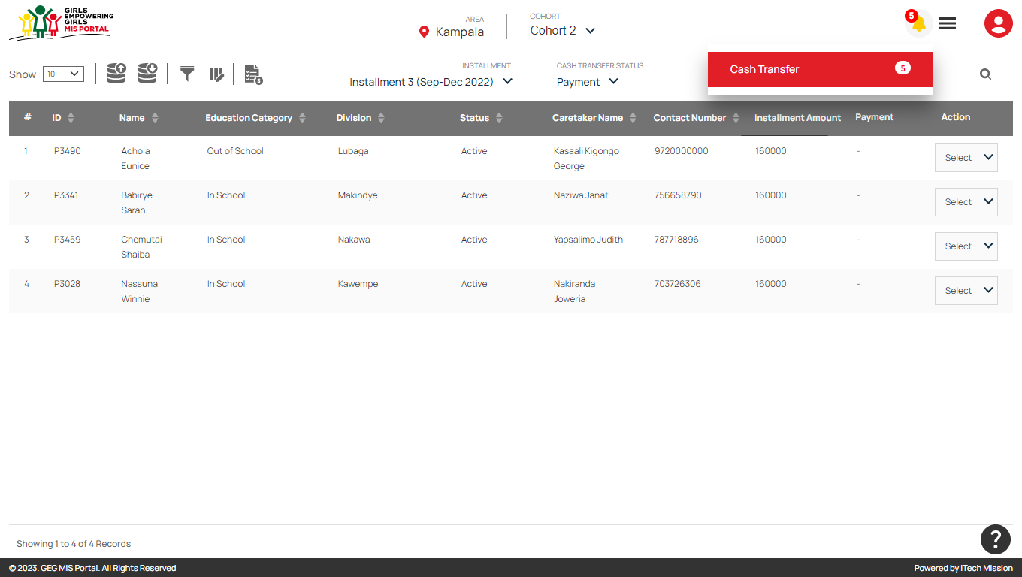

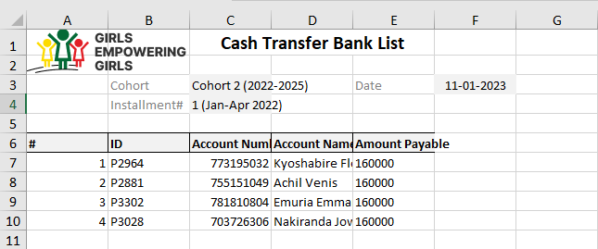Click on the **Bank Payment list** button to download the list of participants whose payment status is not available or is not paid (see below figure).

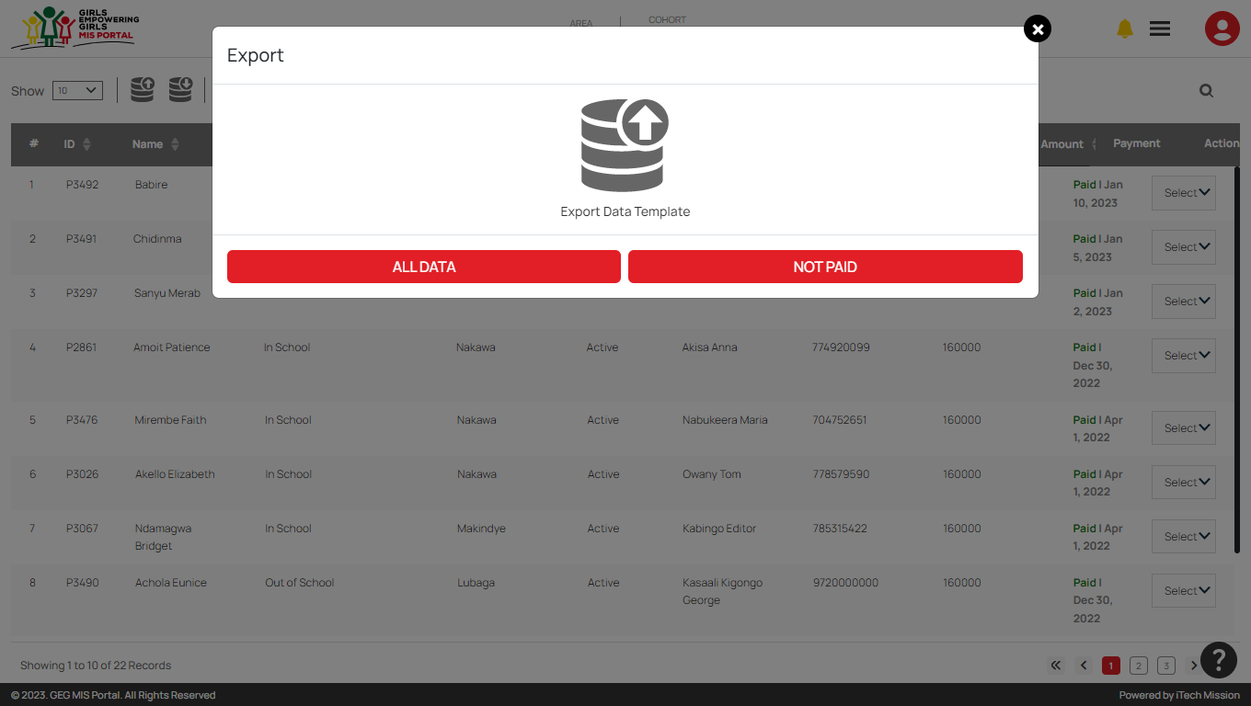By clicking on the **Export** button, a pop-up window appears (see below figure). You can download the payment list of all participants and not paid participants available in the database (see below figure).

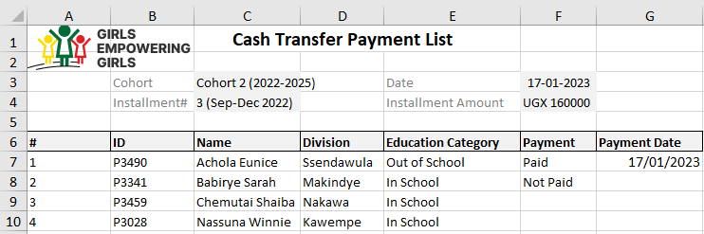By clicking on the **All Data** button, you can download list of all participants available with their payment status in CSV format (see below figure).

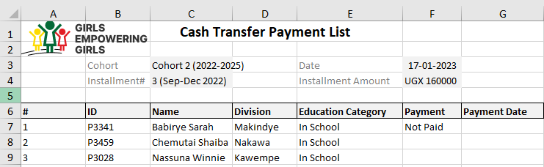By clicking on the **Not Paid** button, you can download the list of participants whose payment status is not available or is not paid in CSV format (see below figure).

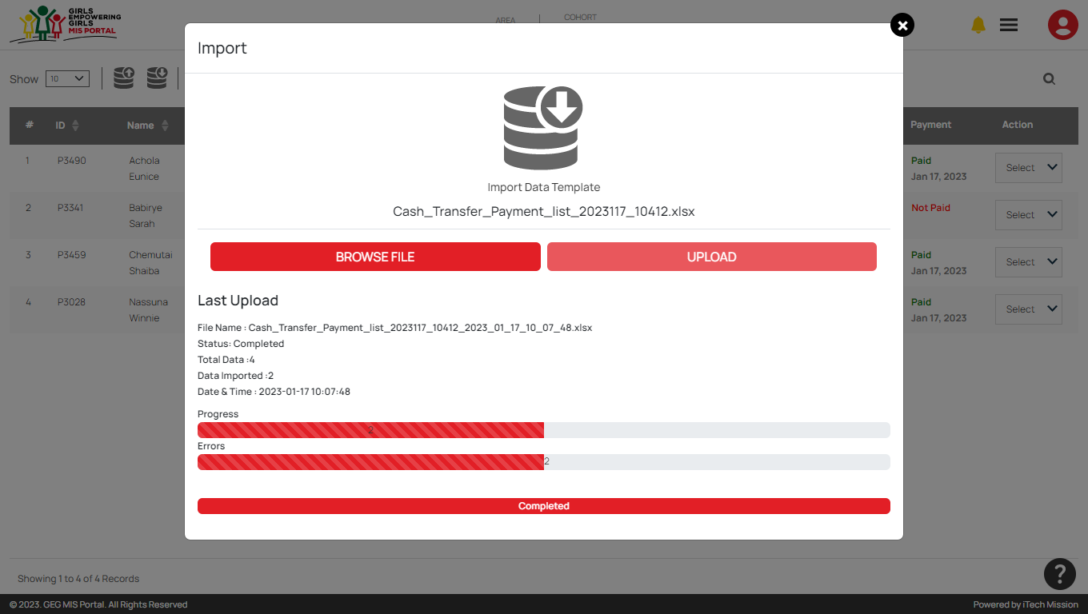To update the payment status of bulk participants at once, you can edit the downloaded payment file and upload the file after entering all required details by clicking on **Import** option (see figure below).

To update payment status, navigate to **Cash Transfer** module and select **Payment** from cash transfer status dropdown. Click to select Pay from the Payment column to update the payment status of selected participant (see below figure).

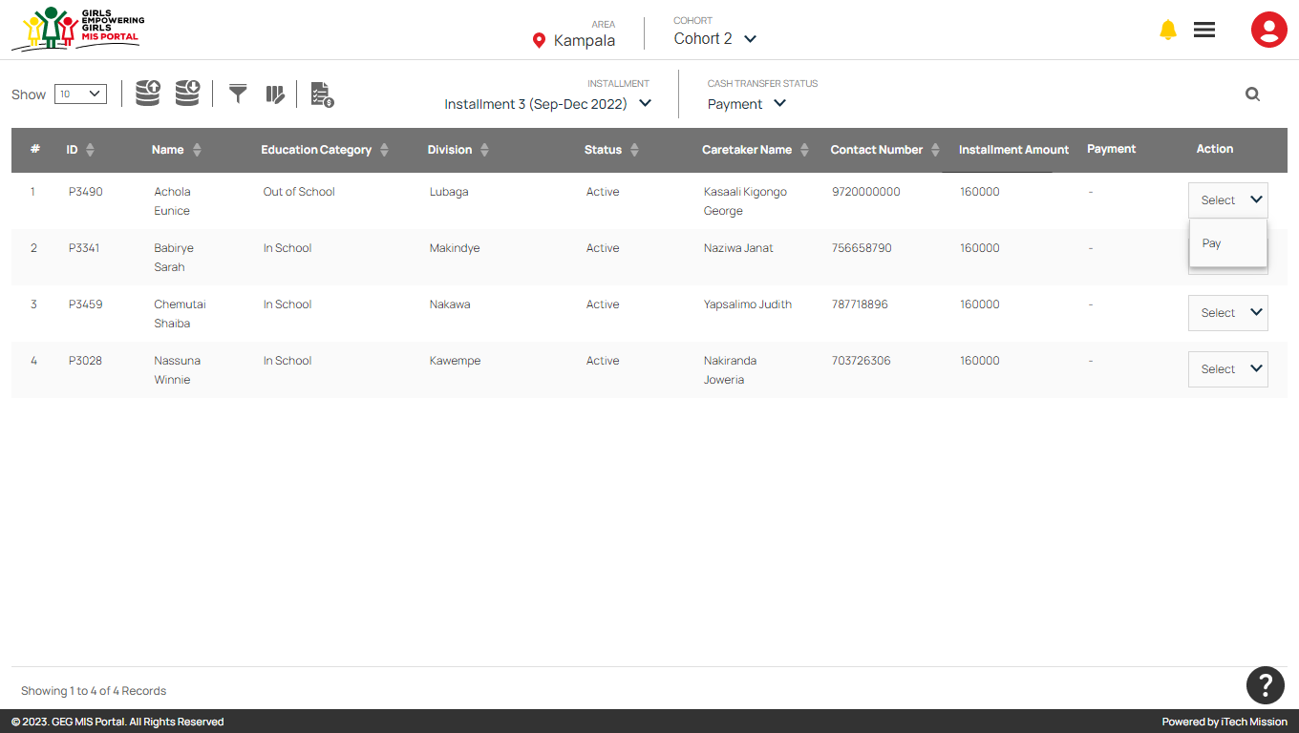

A payment popup window appears, click to select Yes/No in the payment status dropdown. If clicked **Yes**, an additional date field will be added to enter payment date (see below figures). After entering all details, click on OK to save payment details.

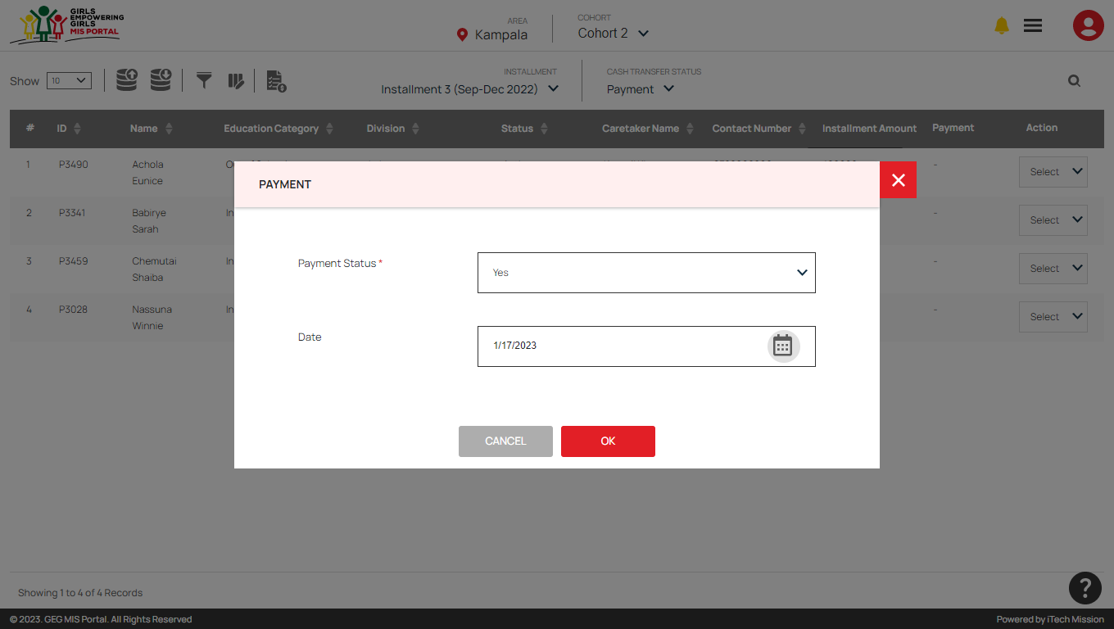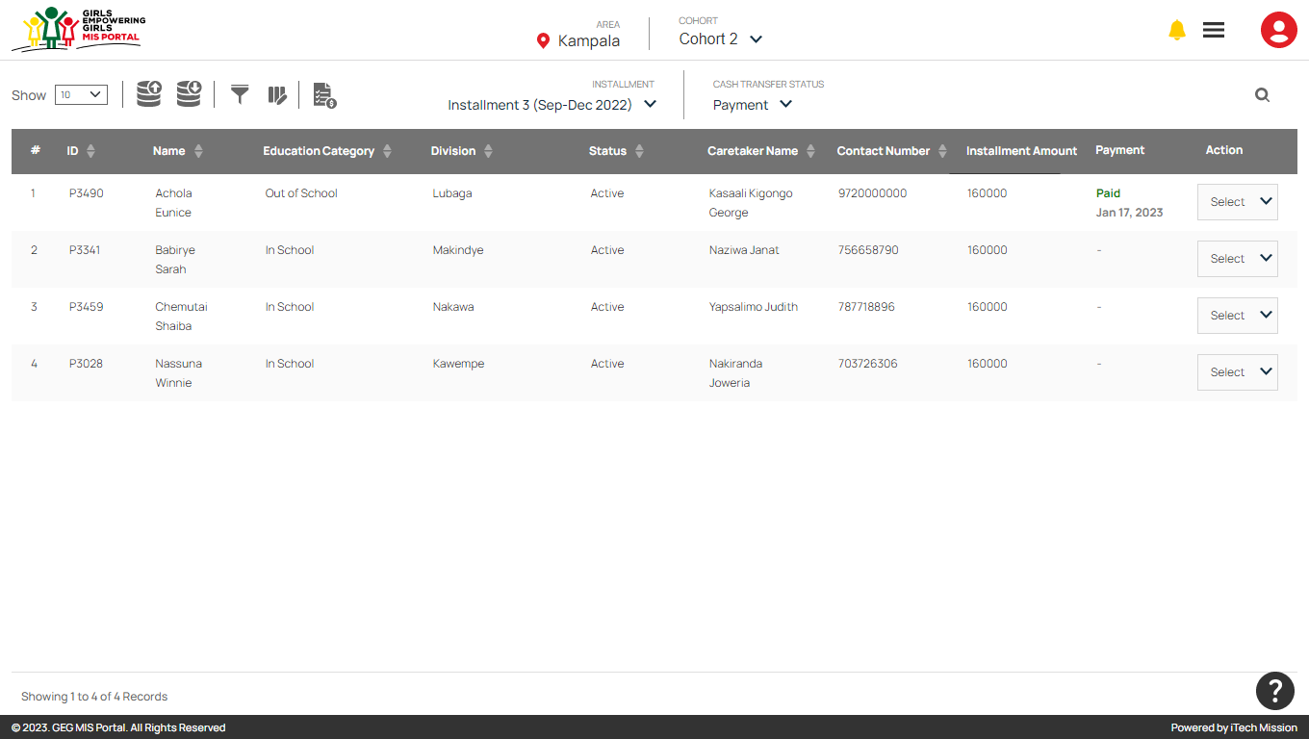

END OF THE DOCUMENT